**Teenage Business Writing Contest**

**2025**

**Revitalizing Nagasaki:**

**Unlocking Global Potential Through Regional Innovation and International Collaboration**

**Presented by**

**Name**

**School**

**Age**

**July 2025**

**Revitalizing Nagasaki: Unlocking Global Potential Through Regional Innovation and International Collaboration**

**1. Introduction** Nagasaki, historically known as Japan's gateway to the world, now stands at a crossroads. Once a vibrant hub for trade and culture, the prefecture faces severe demographic and economic challenges. With a rapidly aging population, consistent net out-migration, and a declining industrial base, Nagasaki's regional economy is under significant strain. However, these challenges present an opportunity for reinvention. By leveraging its historical identity, strategic location, and natural beauty, Nagasaki can craft a revitalization model that combines tourism, technology, education, and international cooperation.

This paper analyzes the key structural issues facing Nagasaki through comparative data, primarily with Fukuoka Prefecture, and proposes a solution centered around global discovery tourism, digital education exchanges, and local entrepreneurship. By understanding Nagasaki’s struggles and contrasting them with a neighboring success story, we can develop an actionable, scalable strategy to transform the prefecture into a 21st-century model of regional revitalization.

**2. Demographic and Economic Challenges** According to RESAS and Raida data, Nagasaki has experienced continuous population decline, losing over 2,000 people per year since 2015. Net migration remains negative, while neighboring Fukuoka records significant population inflows. The prefecture's working-age population (15–64) shrinks at a rate of 1.5% annually, and its elderly population (65+) now exceeds 34%.

|  |  |  |
| --- | --- | --- |
| **Indicator** | **Nagasaki** | **Fukuoka** |
| Population (2022) | 1.27M | 5.1M |
| Population Decline Rate | -1.3% annually | +0.4% annually |
| Elderly Rate (65+) | 34% | 28% |
| Working Age Pop. Change | -1.5% annually | +0.6% annually |
| GDP per Capita | $28,000 | $35,000 |
| Tourist Visits (2022) | 1.2M | 6.5M |

These statistics reveal Nagasaki’s challenges in workforce sustainability, fiscal growth, and attractiveness to both tourists and long-term residents. A continued decline may result in reduced tax revenue, shrinking educational institutions, and increased health care burdens. The prefecture’s younger population is dwindling, and without a revitalization plan, the regional economy could spiral further into decline. According the RESAS analysis, Nagasaki City alone will lose more than 6% population in 2025 as shown in the following diagram.

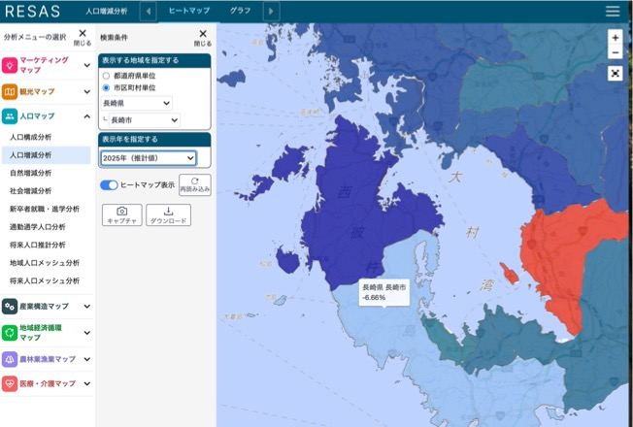

**3. Comparative Insight: Why Fukuoka Is Thriving** Fukuoka's success lies in its strategic investments in startups, urban design, and international positioning. Fukuoka City, designated a "National Strategic Special Zone," offers tax incentives for entrepreneurs and has built a thriving ecosystem for IT and biotech firms. The city promotes inbound migration by fostering international education and bilingual infrastructure. As a result, it has become one of Japan's fastest-growing metropolitan areas, appealing to young professionals and global businesses alike.

While Nagasaki cannot replicate Fukuoka’s scale, it can borrow core principles:

* Develop international educational tourism as a niche strength
* Support high school and university entrepreneurship through contests and incubators
* Attract global talent through strategic marketing campaigns that highlight Nagasaki’s unique value

These insights demonstrate that growth is possible with bold, youth-centered strategies focused on the knowledge economy, global education, and public-private partnerships. According to the RAIDA analysis, the market size of Tourism Spending, Nagasaki is one-third the size of Fukuoka and one-sixth of Tokyo as show in the diagram below.

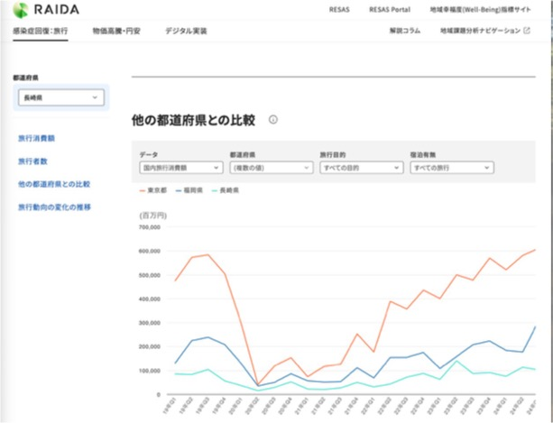

**4. Core Issues to Address**

* **Aging Society:** With over one-third of its population aged 65 and above, Nagasaki must find new roles for seniors while attracting young professionals. Programs that support active aging, intergenerational learning, and healthcare technology can help turn this challenge into an opportunity.
* **Youth Flight:** Young people leave for Tokyo, Osaka, and Fukuoka due to lack of opportunity. Reversing this trend requires job creation, university-industry collaboration, and innovative educational experiences that provide meaningful pathways for the next generation.
* **Underutilized Tourism Potential:** Despite sites like Gunkanjima, Huis Ten Bosch, and Dejima, Nagasaki's tourism lags far behind. Experiences need to be digital, immersive, and multilingual to appeal to international and domestic visitors. The region's history of peace, cultural fusion, and maritime innovation is a compelling narrative waiting to be shared.
* **Economic Disconnection:** Local businesses face difficulty accessing international markets. Without new economic anchors like tech startups, academic R&D, and sustainable manufacturing, Nagasaki risks being left behind in Japan’s innovation race.

### **5. 1. Why Nagasaki Needs a New Future**

Nagasaki has always held a unique place in Japan’s history. As the only port open to the world for centuries, it was a hub of culture, trade, and international exchange. However, today, Nagasaki faces significant challenges: its population is declining, young people are moving away, and tourism lags behind neighboring regions like Fukuoka.

Yet, these challenges present an opportunity. By leveraging its rich history and global connections, Nagasaki can reinvent itself as a center for educational tourism, attracting students and learners from around the world.

**2. The Global Educational Tourism Opportunity**

Educational tourism is a rapidly growing industry. According to IMARC Group, the global educational tourism market was valued at USD 466.85 billion in 2024 and is projected to reach USD 1,291.50 billion by 2033, growing at a CAGR of 11.37% from 2025 to 2033. [IMARC Group+1IMARC Group+1](https://www.imarcgroup.com/educational-tourism-market?utm_source=chatgpt.com)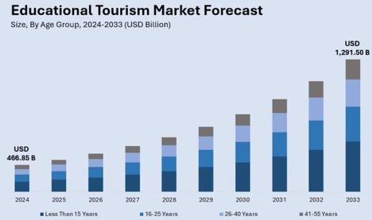

Notably, the United States plays a pivotal role in this sector, accounting for approximately 73.70% of the market share. This dominance is attributed to its prestigious institutions, diverse programs, and cutting-edge research opportunities, making it a prime destination for international students seeking degrees, short-term exchanges, or specialized training.

Nagasaki can tap into this growing market by offering unique educational experiences that combine its historical significance with modern learning opportunities.

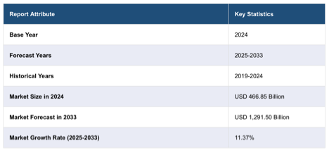

**3. What Makes Nagasaki Special**

Nagasaki's unique attributes make it an ideal destination for educational tourism:

* **Rich History**: From its role in international trade to its experiences during World War II, Nagasaki offers profound lessons in resilience and peace.
* **Cultural Heritage**: Sites like Gunkanjima and Dejima provide immersive experiences into Japan's past.
* **Natural Beauty**: Its coastal landscapes and serene environment offer a peaceful setting for learning and reflection.

These elements can be integrated into educational programs that attract global learners seeking meaningful experiences.

**4. The Global Discovery Nagasaki Project**

To harness this potential, I propose the **Global Discovery Nagasaki Project**, a comprehensive initiative aimed at revitalizing the region through educational tourism.

**A. International Educational Programs**

* **Collaborations with Airlines and Universities**: Partner with airlines like ANA and United to offer subsidized travel packages for students. Collaborate with local and international universities to develop programs focused on peace studies, environmental sustainability, and cultural exchange.
* **Seasonal Camps**: Organize "Global Discovery" camps that provide immersive learning experiences, combining classroom instruction with field visits to historical sites.

**B. Youth Entrepreneurship Initiatives**

* **Startup Incubators**: Establish co-working spaces and incubators in historical buildings, encouraging students to develop business ideas that blend tradition with innovation.
* **Mentorship Programs**: Connect young entrepreneurs with mentors from both local communities and international organizations to guide their ventures.

**C. Community Engagement**

* **Senior Participation**: Involve senior citizens as cultural ambassadors, sharing their stories and experiences with visitors.
* **Intergenerational Programs**: Foster connections between youth and elders through collaborative projects, promoting mutual learning and respect.

**D. Alignment with Sustainable Development Goals (SDGs)**

* Integrate SDGs into all programs, emphasizing goals like quality education, decent work, and sustainable communities.

**5. Anticipated Outcomes**

**Short-Term (1–2 Years):**

* Attract 3,000 international students through educational programs.
* Launch 10 student-led startups focused on tourism and cultural preservation.
* Increase tourism by 25%, boosting the local economy.

**Mid-Term (3–5 Years):**

* Reverse population decline by creating job opportunities and enhancing the region's appeal.
* Establish Nagasaki as a leading destination for educational tourism in Asia.
* Foster a vibrant community where history, culture, and innovation coexist.

**6. Conclusion**

Nagasaki stands at a crossroads. By embracing its historical legacy and leveraging the booming educational tourism market, it can chart a path toward revitalization. The Global Discovery Nagasaki Project offers a blueprint for sustainable growth, community engagement, and international collaboration.

As a student passionate about global connections and cultural exchange, I believe in Nagasaki's potential to inspire and educate future generations. Let's transform challenges into opportunities and reimagine Nagasaki's future together.

Nagasaki’s challenges are emblematic of rural Japan’s broader struggle. Yet, by embracing internationalism, youth-driven innovation, and future-facing education, Nagasaki can rediscover its strength as a bridge between Japan and the world. Its compelling narrative of resilience—from wartime tragedy to peaceful diplomacy—can serve as a global magnet for dialogue, creativity, and action.

With bold partnerships and a commitment to the next generation, the prefecture can build a model for inclusive, sustainable revitalization that inspires other regions in Japan and beyond. Policymakers, educators, and business leaders must now act together—locally and globally—to secure Nagasaki’s future.

The time has come for Nagasaki to lead again—not by turning back the clock, but by forging new pathways with the global community. As one of Japan’s most culturally significant regions, Nagasaki can rise as a pioneer of 21st-century regional revival rooted in history, powered by youth, and shared with the world.

